SOFTWARE ENGINEERING PROJECT CONFERENCE ROOM MANAGEMENT SYSTEM SOFTWARE DESIGN DOCUMENT

PREPARED BY

1. SAMPREETH NADIG (SRN: PES1UG20CS371)
2. SANATH SREEKANTH K (SRN: PES1UG20CS373)
3. SANMAT SANJAYAKUMAR PAYAGOUDAR (SRN: PES1UG20CS385)
4. SHAMITH V S (SRN:PES1UG20CS390)

TABLE OF CONTENTS

|  |  |
| --- | --- |
| **TITLE** | **PAGE** |
| SCOPE | 1 |
| PURPOSE | 1 |
| SYSTEM OVERVIEW | 1 |
| ARCHITECTURE DIAGRAM | 2 |
| USER USE CASE DIAGRAM | 3 |
| ADMINISTRATOR USE CASE  DIAGRAM | 3 |
| USER ACTIVITY DIAGRAM | 4 |
| ADMINISTRATOR ACTIVITY DIAGRAM | 5 |
| USER SEQUENCE DIAGRAM | 6 |
| ADMINISTRATOR SEQUENCE DIAGRAM | 7 |
| CLASS DIAGRAM | 8 |
| COMPONENT DIAGRAM | 9 |
| DATA FLOW DIAGRAM | 10 |

The purpose of the document is to cover the design and analysis phase of the life-cycle development plan of the desired web- based conference room management system architecture.

**SCOPE**

The scope of the Conference Room Reservation System(CRRS) is to create an online web-interface for the users to check the availability and book the room from any part of the world. This system will be an alternative to the traditional offline way of checking available rooms and book them.

# SYSTEM OVERVIEW

The system considers customer and Conference Room manager perspectives. It has CRRS – where customers are able to book the rooms and use system functions described in his document, while for the administrative use there is a separate environment, where accounting, logistics and all relevant operations run. Both systems are based on the common database.

They are integrated with each other, meaning the relevant data is exchanged.

The subsystem “User Interface” is an element of CRRS and it represents the web-interface for customer to book rooms online according to their choice of selection.

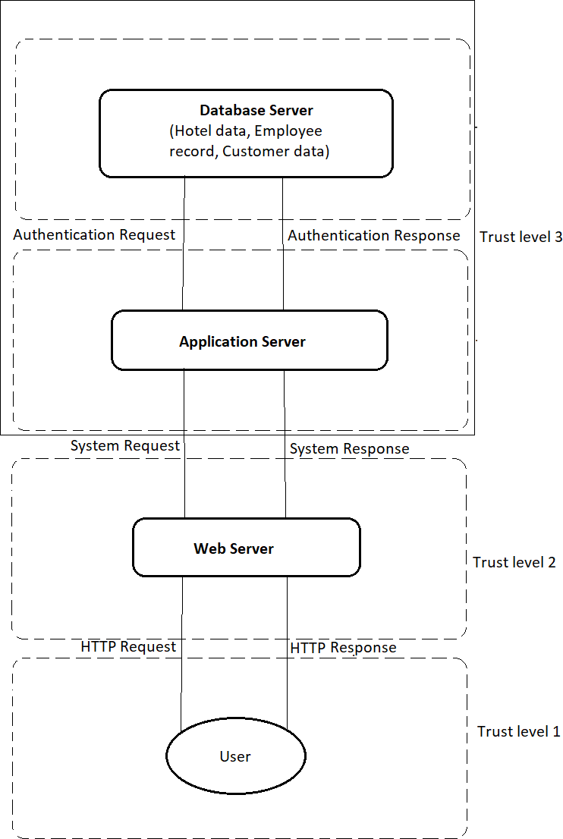

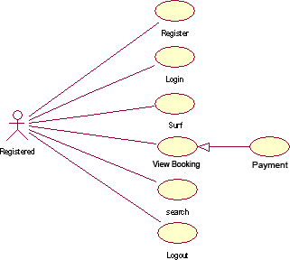

# ADMIN USE CASE DIAGRAM

